Automation of SAP Field glass Website
End User Guide
Version 1

TABLE OF CONTENTS
1 PUPRPOSE OF THE DOCUMENT 1
2 Introduction 2
3 Pre ReQUISITES 5
4 Steps for EXECution 6
5 Tools USEd 8
6 CONCLUSION 9

- PUPRPOSE OF THE DOCUMENT
The purpose of this document is to guide the end user on how to setup the file on their local system so as to enable the execution of the Automation done on www.fieldglass .net. The document also specifies the input parameters and the expected output. Pre requisites for the execution to be performed without any errors is also specified in this document. At the end of the document, details about the expected output are discussed.

Introduction

The website ‘www.Fieldglass.net’, contains information on the latest job postings. Depending on the status of the job posting, these are listed on the website. This is explained with the help of the screenshots below:

Logging in to www.fieldglass.net

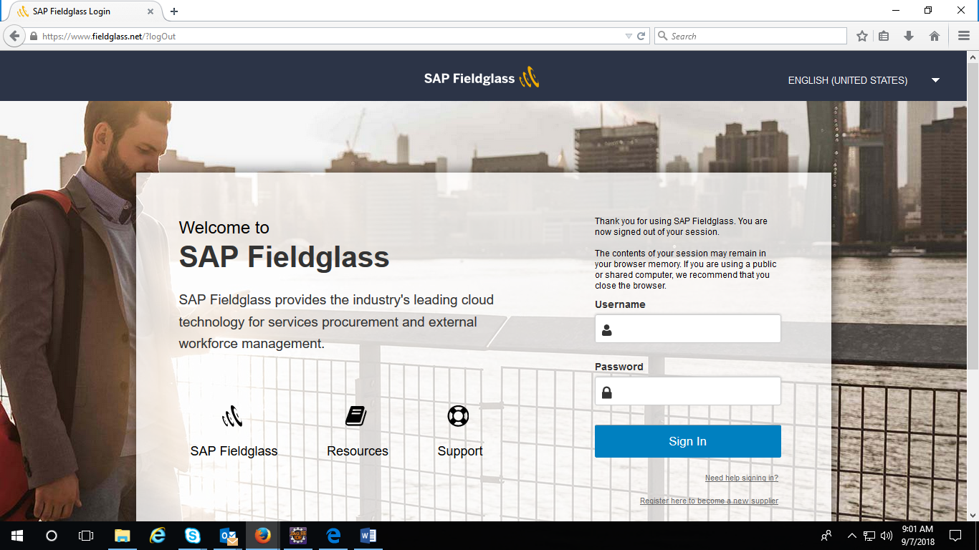

Enter the correct username and password and click on the login button.

After logging in, click on View as shown below:

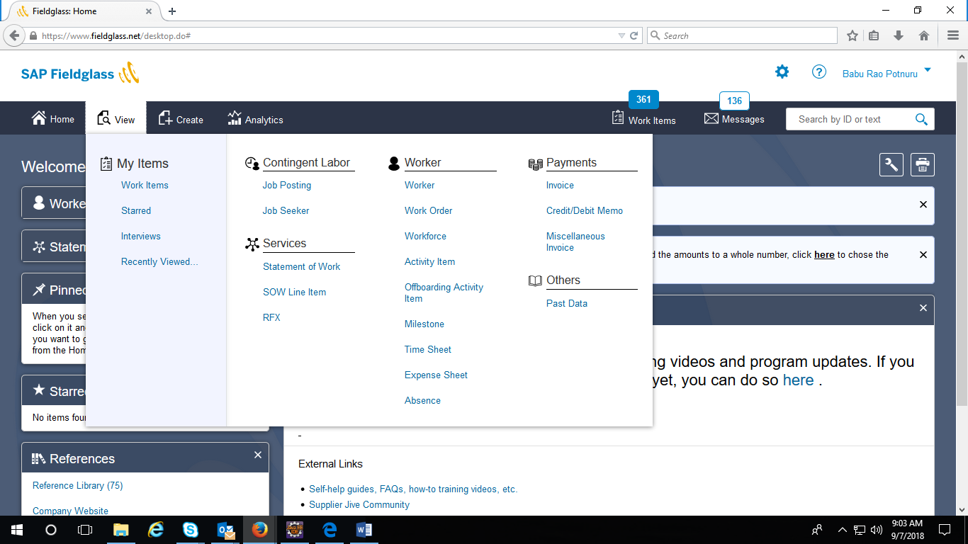

Click on Job Posting and the following page is displayed

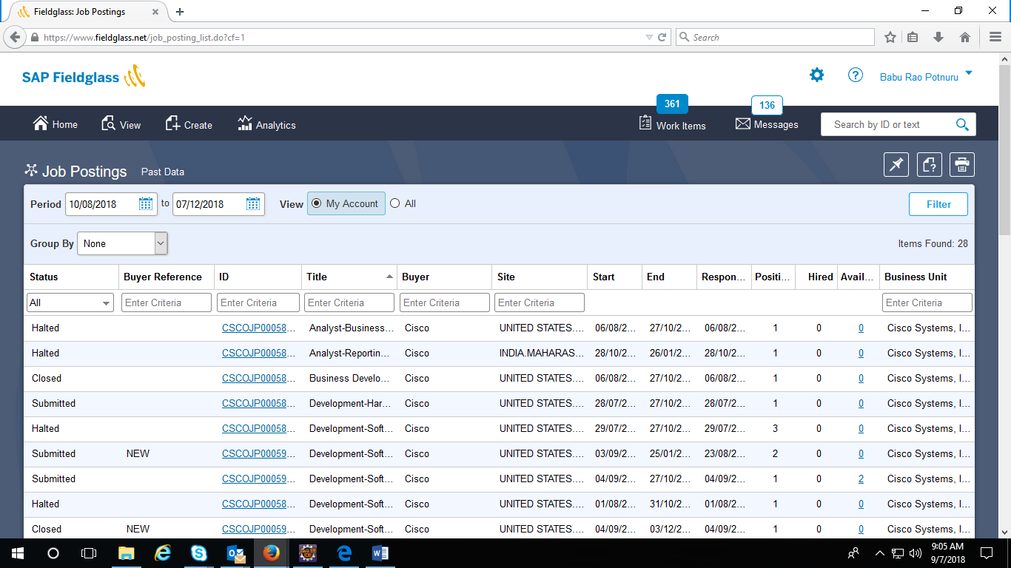

Select the status field. The statuses available in the dropdown are All, Approval Paused, Closed, Declined, Halted, Pending Approval, Rejected, Submitted, Withdrawn

Depending on the status field the next page is displayed. Here we are selecting closed.

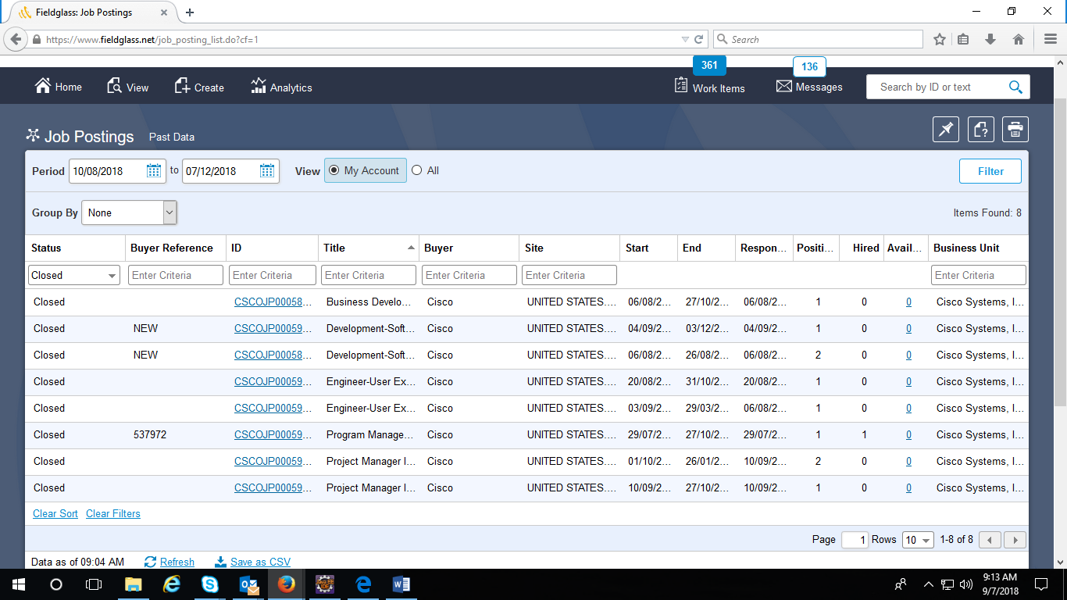

On this page we click on any one of the cisco id links and the following page is displayed.

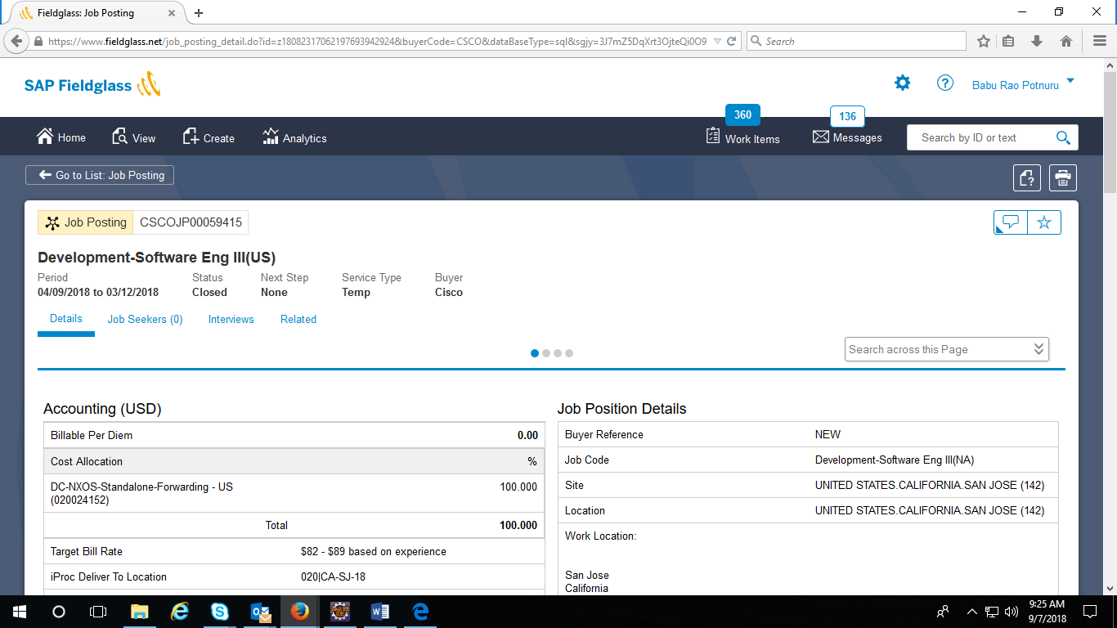

Details pertaining to the Cisco Id are displayed here. All the above steps are automated and the details from this page are captured in excel sheets.

Pre ReQUISITES

JDK 1.8 should be installed

Firefox browser should be installed

Steps for EXECution

Place the folder in the D drive. Name of the folder is FieldglassAutomation. Please refer to the screenshot below for the folder structure.

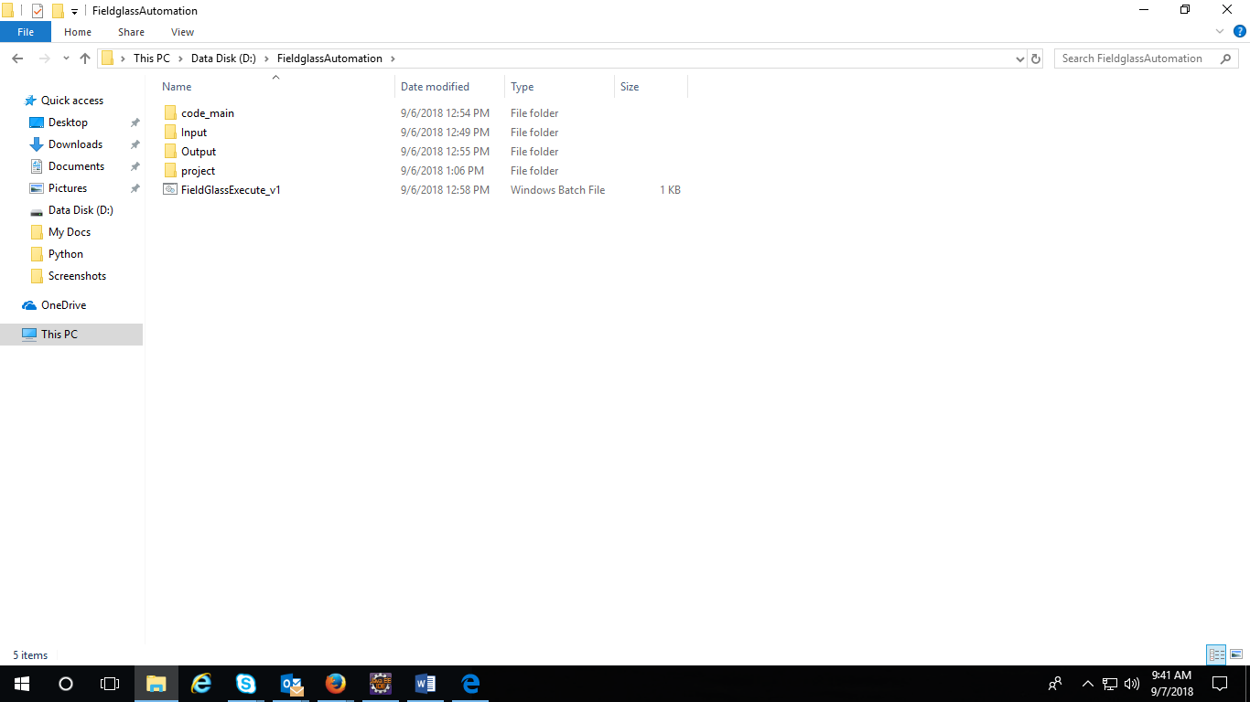

Go to Input folder. This folder has the input excel sheets.

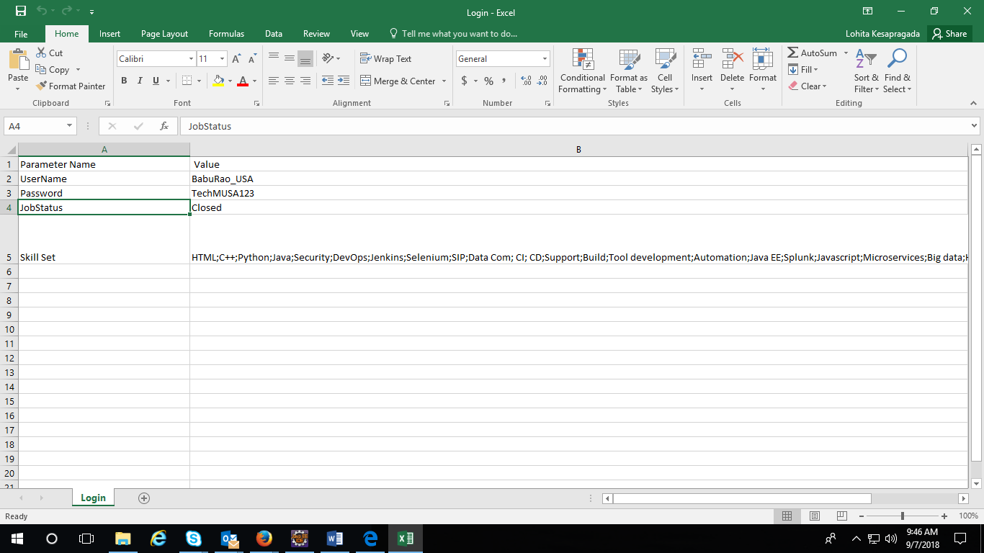

The end user can change the value of the username, password, status and skill set. The different status values can be All, Approval Paused, Closed, Declined, Halted, Pending Approval, Rejected, Submitted and Withdrawn. Skill sets can be updated here, if the user feels the need for the same.

Execute the batch file in the FieldglassAutomation folder

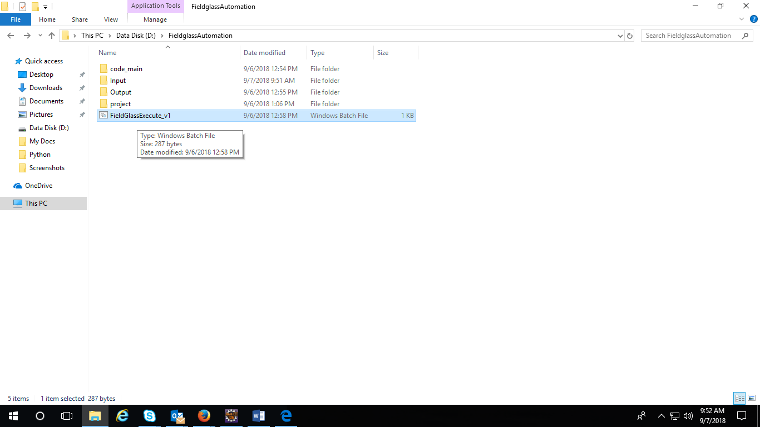

Check for output in the Output folder

Tools USEd

Selenium Web driver- 2.53

Java- jdk 1.8

Eclipse- Luna 32

CONCLUSION

The automation of the website fieldglass.net has been achieved and the results can be viewed in the Output folder

